**Session 9: Date- 3rd October 2023**

**Topics: Bootstrap**

1. **Padding**

<div class="container-fluid p-5">

Hi, this is html div not styled with css.

</div>

**Output-**



1. **Margins**

<div class="container-fluid mt-5">

Hi, this is html div not styled with css.

</div>

**Output-**



1. **Background-color**

<div class="container bg-primary p-5"></div>

<div class="container bg-secondary p-5"></div>

<div class="container bg-info p-5"></div>

<div class="container bg-dark p-5"></div>

<div class="container bg-light p-5"></div>

<div class="container bg-warning p-5"></div>

<div class="container bg-success p-5"></div>

<div class="container bg-danger p-5"></div>

**Output-**



1. **Responsive containers**

<h3>Responsive containers</h3>

<div class="container-sm border p-5"></div>

<div class="container-md border p-5"></div>

<div class="container-lg border p-5"></div>

<div class="container-xl border p-5"></div>

<div class="container-xxl border p-5"></div>

<hr>

**Output-**

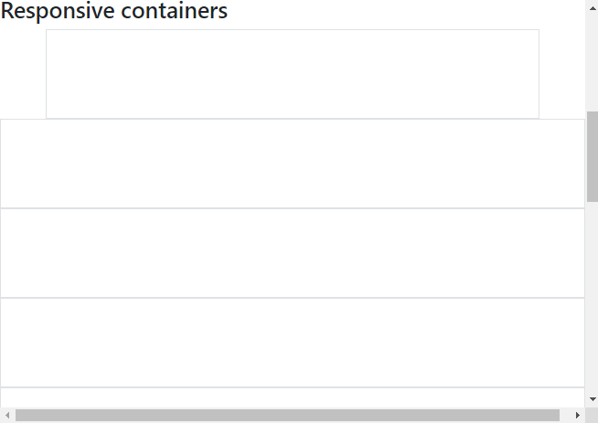

1. **Text colors**

<h2>Text colors</h2>

<p class="text-primary">text-primary</p>

<p class="text-secondary">text-secondary</p>

<p class="text-info">text-info</p>

<p class="text-dark">text-dark</p>

<p class="text-light">text-light</p>

<p class="text-warning">text-warning</p>

<p class="text-success">text-sucess</p>

<p class="text-danger">text-danger</p>

**Output-**

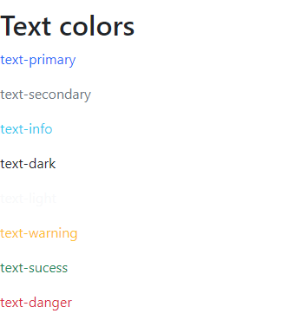

1. **Grid system**

<!--grid system-->

<div class="row border">

<div class="col">column 1</div>

<div class="col">column 2</div>

<div class="col">column 3</div>

</div>

<div class="row border bg-warning">

<div class="col">column 1</div>

<div class="col">column 2</div>

<div class="col">column 3</div>

</div>

**Output-**



1. **Unequal grid system**

<!--unequal grid system-->

<div class="row border bg-success">

<div class="col-sm-4">col 1</div>

<div class="col-sm-8">col 2</div>

</div>

**Output-**



1. **Bootstrap-5 Table**

<h2>Bootstrap-5 Table</h2>

<div class="container p-5">

<table class="table table-bordered table-striped table-hover">

<tr class="table-info">

<th>Name</th><th>Email</th><th>City</th>

</tr>

<tr>

<th>Falguni Parab</th><th>falguni@gmail.com</th><th>Mumbai</th>

</tr>

<tr>

<th>Sahil Parab</th><th>sahil@gmail.com</th><th>Mumbai</th>

</tr>

<tr>

<th>Vijay Sanap</th><th>vijay@gmail.com</th><th>Mumbai</th>

</tr>

<tr>

<th>Karan Panchal</th><th>karan@gmail.com</th><th>Mumbai</th>

</tr>

</table>

**Output-**

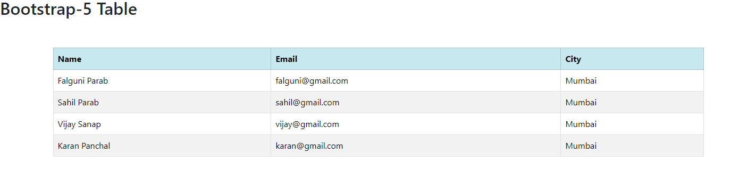

1. **Bootstrap-5 Images**

<h2>Bootstrap-5 images</h2>

<div class="container"></div>

<img src="indian-flag.png" alt="India" class="rounded" height="200px" width="200px">

<img src="indian-flag.png" alt="India" class="rounded-circle" height="200px" width="200px">

<img src="indian-flag.png" alt="India" class="img-thumbnail" height="200px" width="200px">

**Output-**

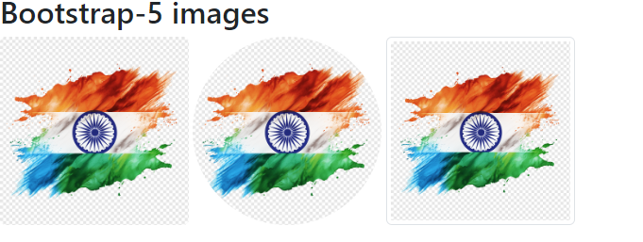

1. **Bootstrap-5 Alerts**

<h2>Bootstrap-5 Alerts</h2>

<div class="container">

<div class="alert alert-primary">Alert!</div>

<div class="alert alert-secondary">Alert!</div>

<div class="alert alert-info">Alert!</div>

<div class="alert alert-dark">Alert!</div>

<div class="alert alert-light">Alert!</div>

<div class="alert alert-warning">Alert!</div>

<div class="alert alert-success">Alert!</div>

<div class="alert alert-danger">Alert!</div>

</div>

**Output-**

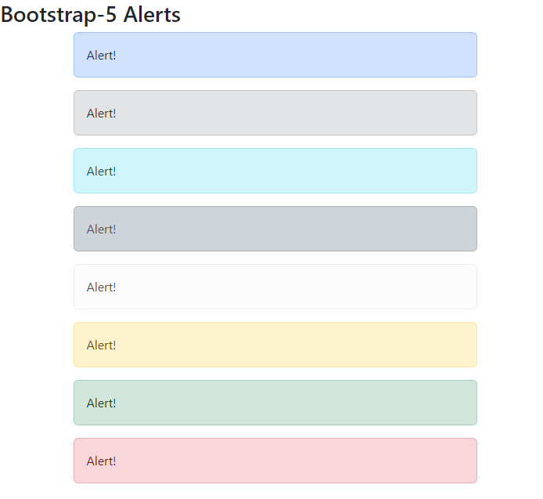

1. **Bootstrap-5 CSS+JS events**

<h2>Bootstrap-5 Alerts</h2>

<div class="container">

<div class="alert alert-primary alert-dismissible">Alert!

<button type="button" class="btn-close" data-bs-dismiss="alert"></button>

</div>

<div class="alert alert-secondary alert-dismissible">Alert!

<button type="button" class="btn-close" data-bs-dismiss="alert"></button>

</div>

<div class="alert alert-info alert-dismissible">Alert!

<button type="button" class="btn-close" data-bs-dismiss="alert"></button>

</div>

<div class="alert alert-dark alert-dismissible">Alert!

<button type="button" class="btn-close" data-bs-dismiss="alert"></button>

</div>

<div class="alert alert-light alert-dismissible">Alert!

<button type="button" class="btn-close" data-bs-dismiss="alert"></button>

</div>

<div class="alert alert-warning alert-dismissible">Alert!

<button type="button" class="btn-close" data-bs-dismiss="alert"></button>

</div>

<div class="alert alert-success alert-dismissible">Alert!

<button type="button" class="btn-close" data-bs-dismiss="alert"></button>

</div>

<div class="alert alert-danger alert-dismissible">Alert!

<button type="button" class="btn-close" data-bs-dismiss="alert"></button>

</div>

</div>

**Output-**

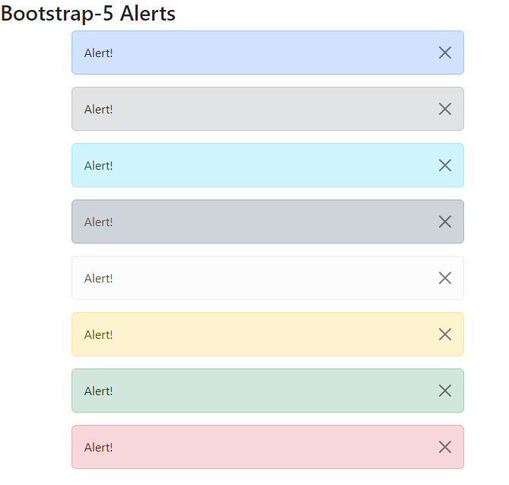

1. **Bootstrap-5 button events**

<hr>

<div class="container p-2">

<button type="button" class="btn btn-primary">Primary</button>

<button type="button" class="btn btn-secondary">Secondary</button>

<button type="button" class="btn btn-info">Info</button>

<button type="button" class="btn btn-light">Light</button>

<button type="button" class="btn btn-dark">Dark</button>

<button type="button" class="btn btn-success">Success</button>

<button type="button" class="btn btn-danger">Danger</button>

</div>

<hr>

<div class="container p-2">

<button type="button" class="btn btn-outline-primary">Primary</button>

<button type="button" class="btn btn-outline-secondary">Secondary</button>

<button type="button" class="btn btn-outline-info">Info</button>

<button type="button" class="btn btn-outline-light">Light</button>

<button type="button" class="btn btn-outline-dark">Dark</button>

<button type="button" class="btn btn-outline-success">Success</button>

<button type="button" class="btn btn-outline-danger">Danger</button>

</div>

<hr>

<div class="btn-group">

<button type="button" class="btn btn-warning">Warning</button>

<button type="button" class="btn btn-info">Info</button>

<button type="button" class="btn btn-dark">Dark</button>

</div>

<hr>

<div class="btn-group-vertical">

<button type="button" class="btn btn-warning">Warning</button>

<button type="button" class="btn btn-info">Info</button>

<button type="button" class="btn btn-dark">Dark</button>

</div>

**Output-**

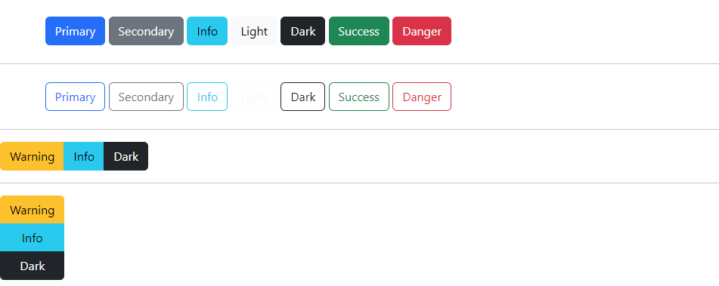

1. **Bootstrap-5 List**

<h2>Bootstrap-5 List</h2>

<div class="container p-2">

<ul class="list-group">

<li class="list-group-item">Web Technology</li>

<li class="list-group-item">DBMS</li>

<li class="list-group-item">Python</li>

</ul>

</div>

**Output-**

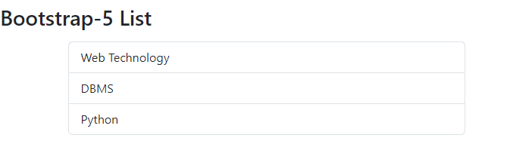

1. **Bootstrap-5 Toast**

<head>

<meta charset="UTF-8">

<meta name="viewport" content="width=device-width, initial-scale=1.0">

<title>Document</title>

<link rel="stylesheet" href="./Assests/css/bootstrap.min.css">

<script src="./Assests/js/bootstrap.bundle.min.js"></script>

</head>

<body>

<p class="h2">Bootstrap-5 Toast</p>

<div class="container bg-info p-5">

<div class="toast show">

<div class="toast-header">MCA FY 2023-25

<button type="button" class="btn-close" data-bs-dismiss="toast"></button>

</div>

<div class="toast-body">

<pre>

Welcome to Web Technology-I session

HTML

CSS

JS, etc.

</pre>

</div>

<div class="toast-footer">

<button type="button" class="btn btn-danger" data-bs-dismiss="toast"></button>

</div>

</div>

</div>

**Output-**

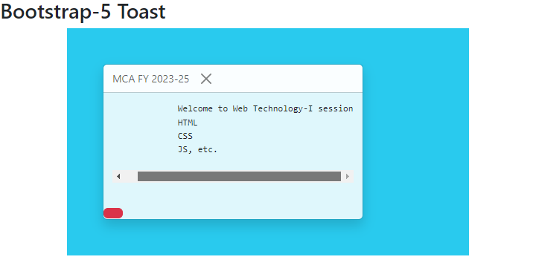

1. **Bootstrap-5 card**

<p class="h2">Bootstrap-5 Card</p>

<div class="container">

<div class="card" style="width: 400px;">

<div class="card-header">India</div>

<img src="indian-flag.png" alt="india" class="card-img-top">

<div class="card-body">

<pre class="card-text">

India is my country and

all Indians are my brothers and sisters.

I love my country and I am proud of its rich

and varied heritage.

I shall always strive to be worthy of it.

I shall give my parents, teachers and all

elders respect and treat everyone with courtesy.

</pre>

</div>

<div class="card-footer">

<a href="#" class="card-link">Click here to know more...</a>

</div>

</div>

</div>

**Output-**

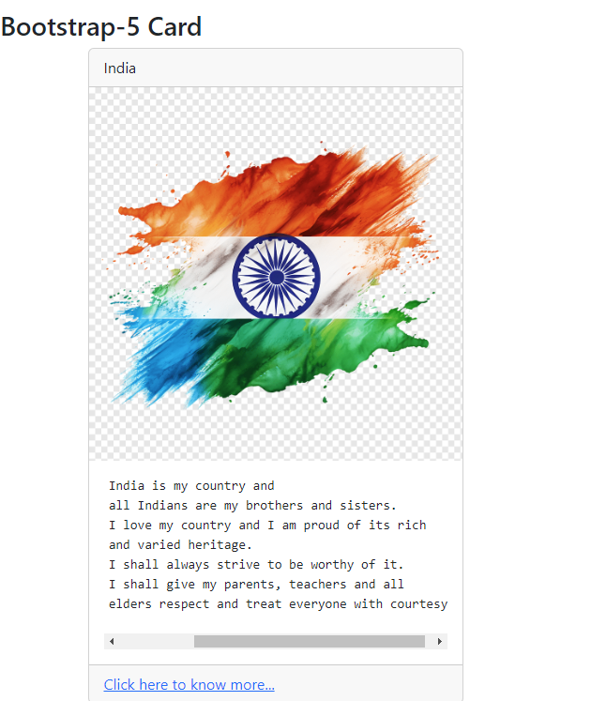

1. **Bootstrap-5 Modal**

<hr>

<p class="h2">Bootstrap-5 Modal</p>

<button type="button" class="btn btn-success" data-bs-toggle="modal" data-bs-target="#mymodal">Click here to Open </button>

<div class="modal" id="mymodal">

<div class="modal-dialog">

<div class="modal-content">

<div class="modal-header">MCA FY 2023-25 Exam Alert!!!&nbsp;&nbsp;

<button type="button" class="btn-close" data-bs-dismiss="modal"></button>

</div>

<div class="modal-body">

<p>This is a dialog box</p>

</div>

<div class="modal-footer">

<button type="button" class="btn btn-danger" data-bs-dismiss="modal"></button>

</div>

</div>

</div>

</div>

**Output-**



